Design DFA using simulator to accept the input string “a”, “a”

and” bac”

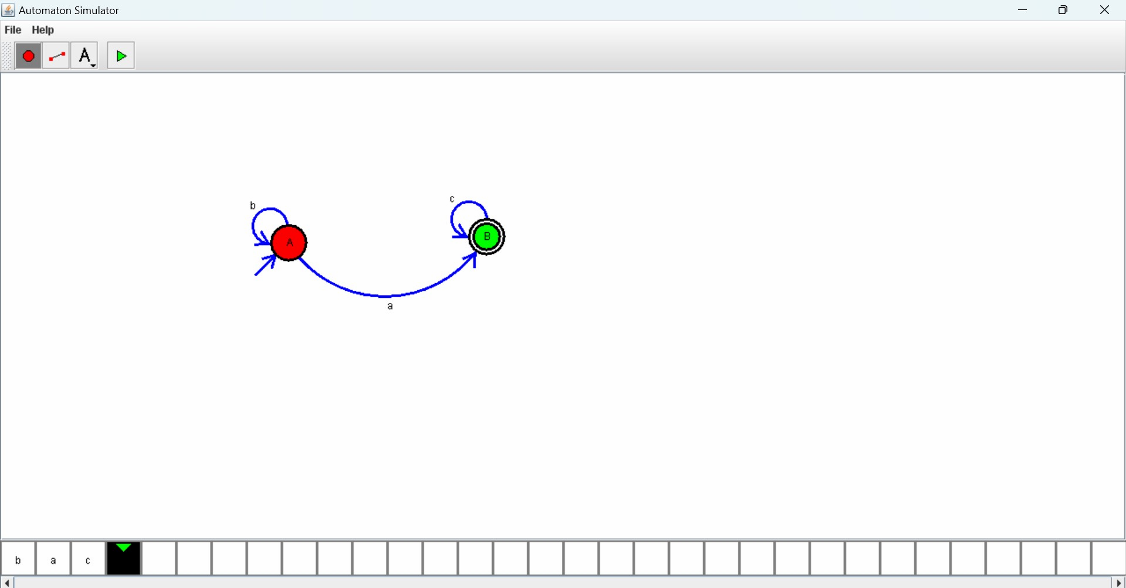

Design PDA using simulator to accept the input string aabb

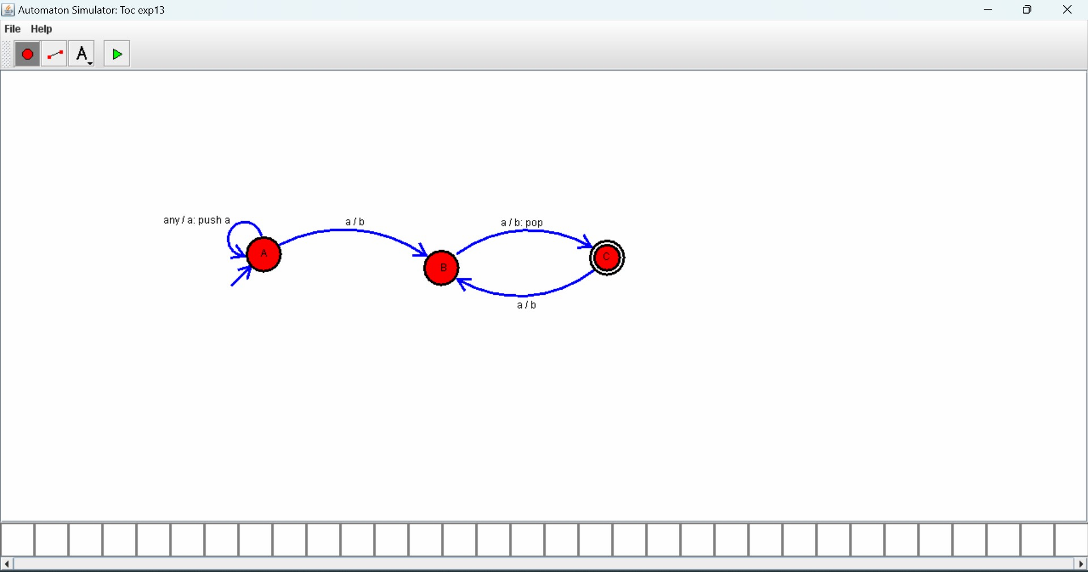

Design PDA using simulator to accept the input string a^nb^2n



Design TM using simulator to accept the input string a ^nb^ n

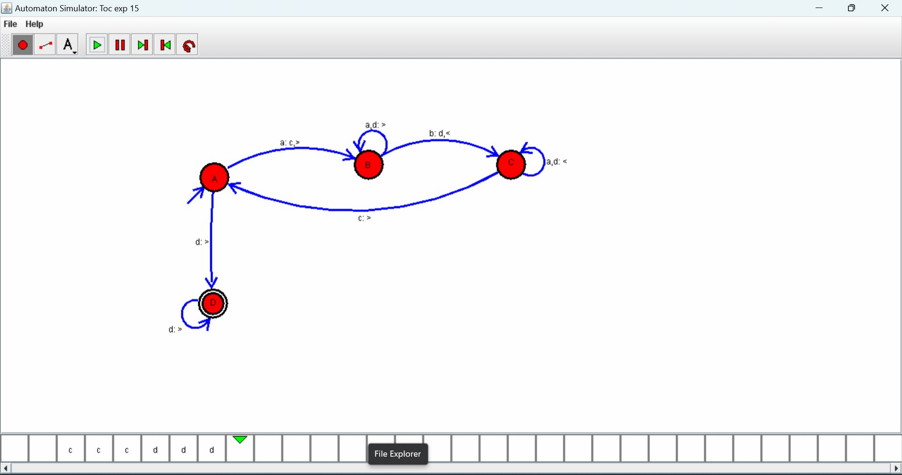

. Design TM using simulator to accept the input string a^nb^2n

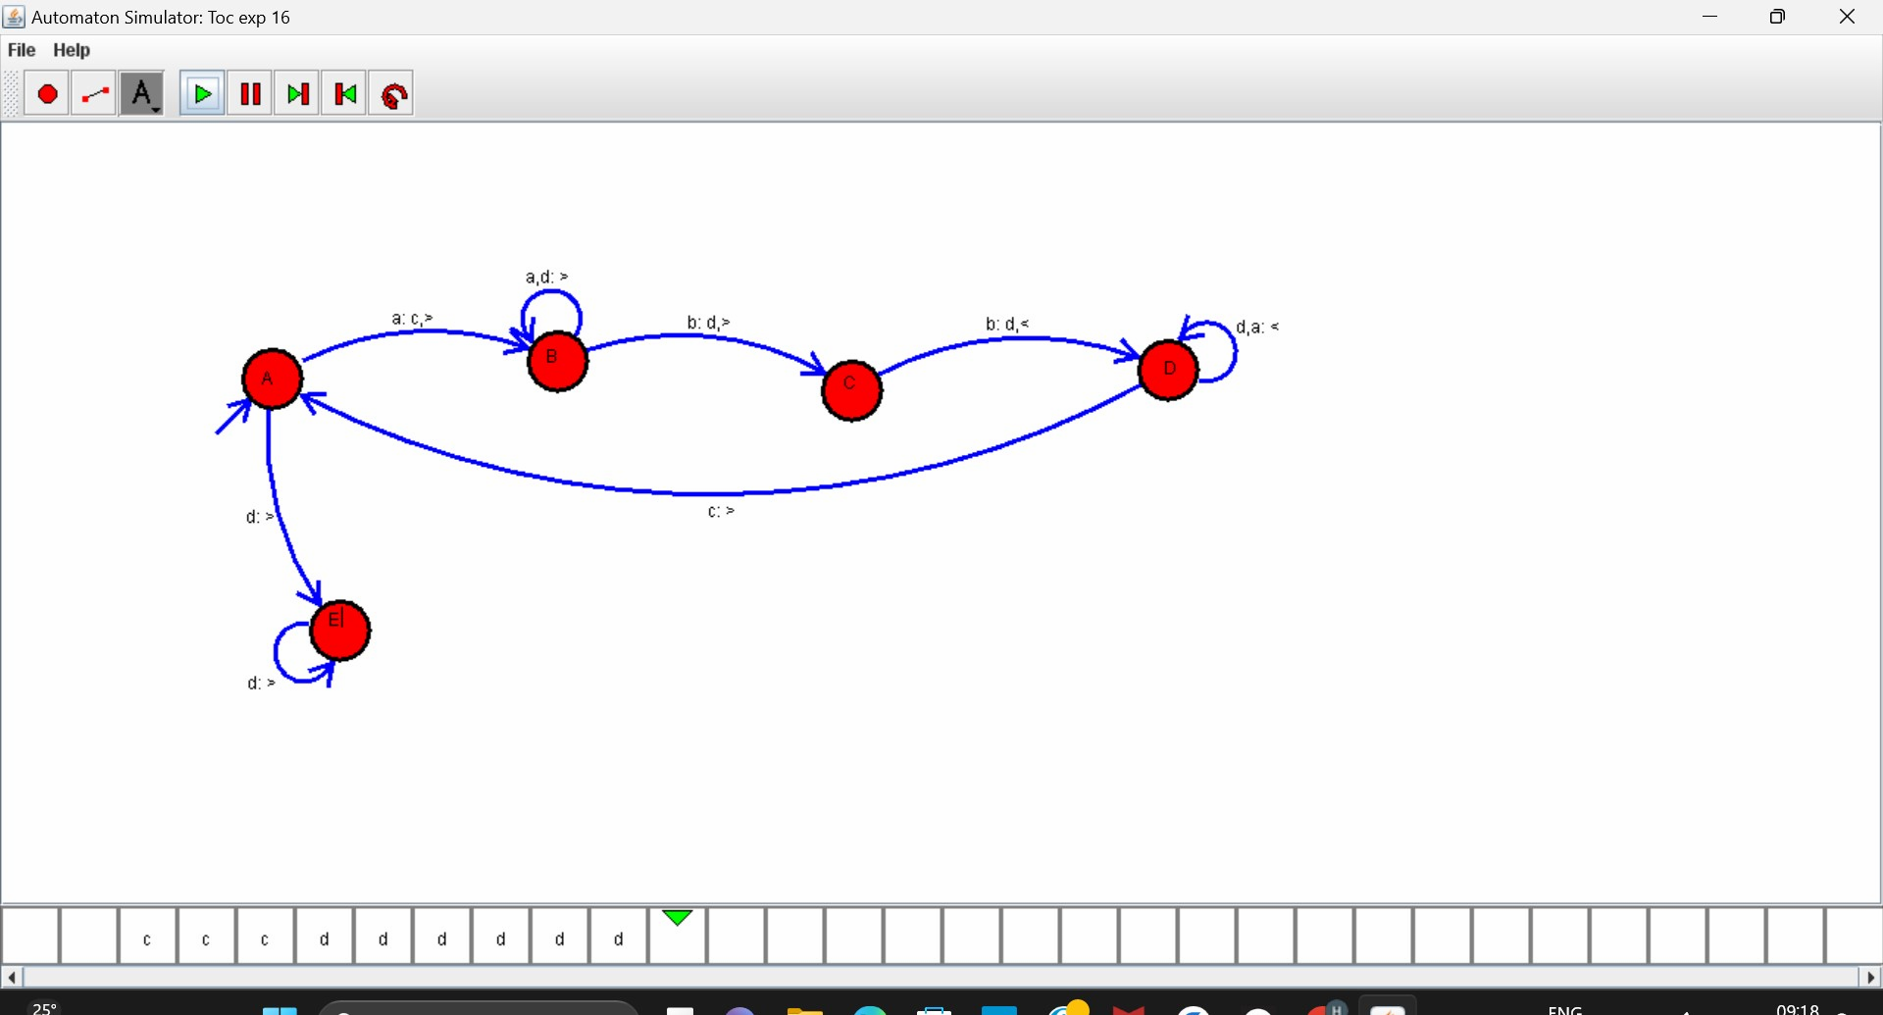

Design TM using simulator to accept the input string Palindrome

Ababa

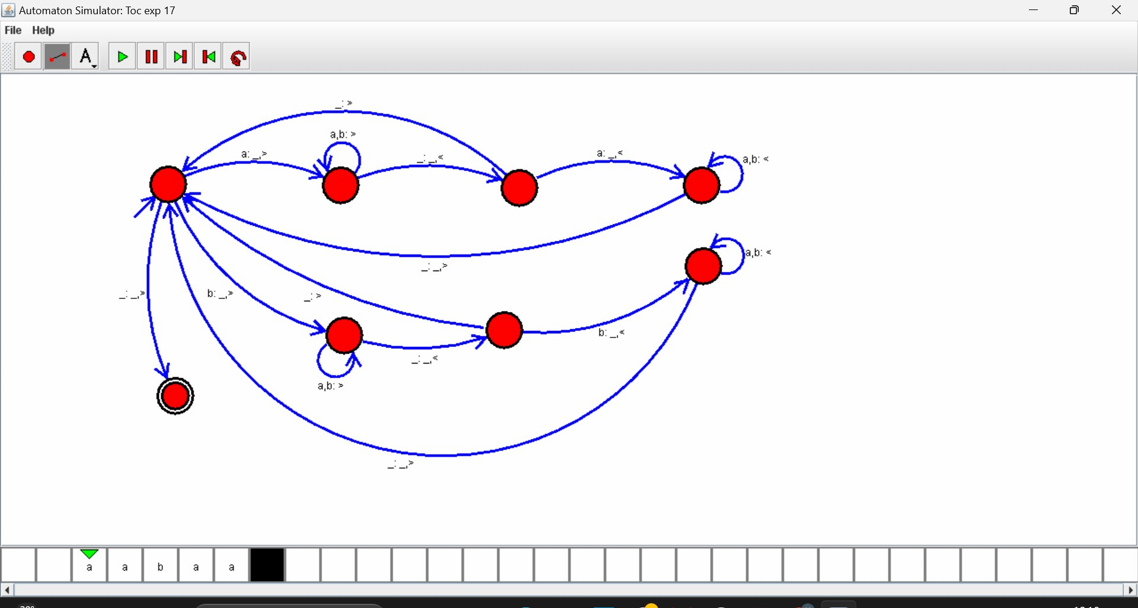

W cv

Design TM using simulator to perform addition of ‘aa’ and ‘aaa

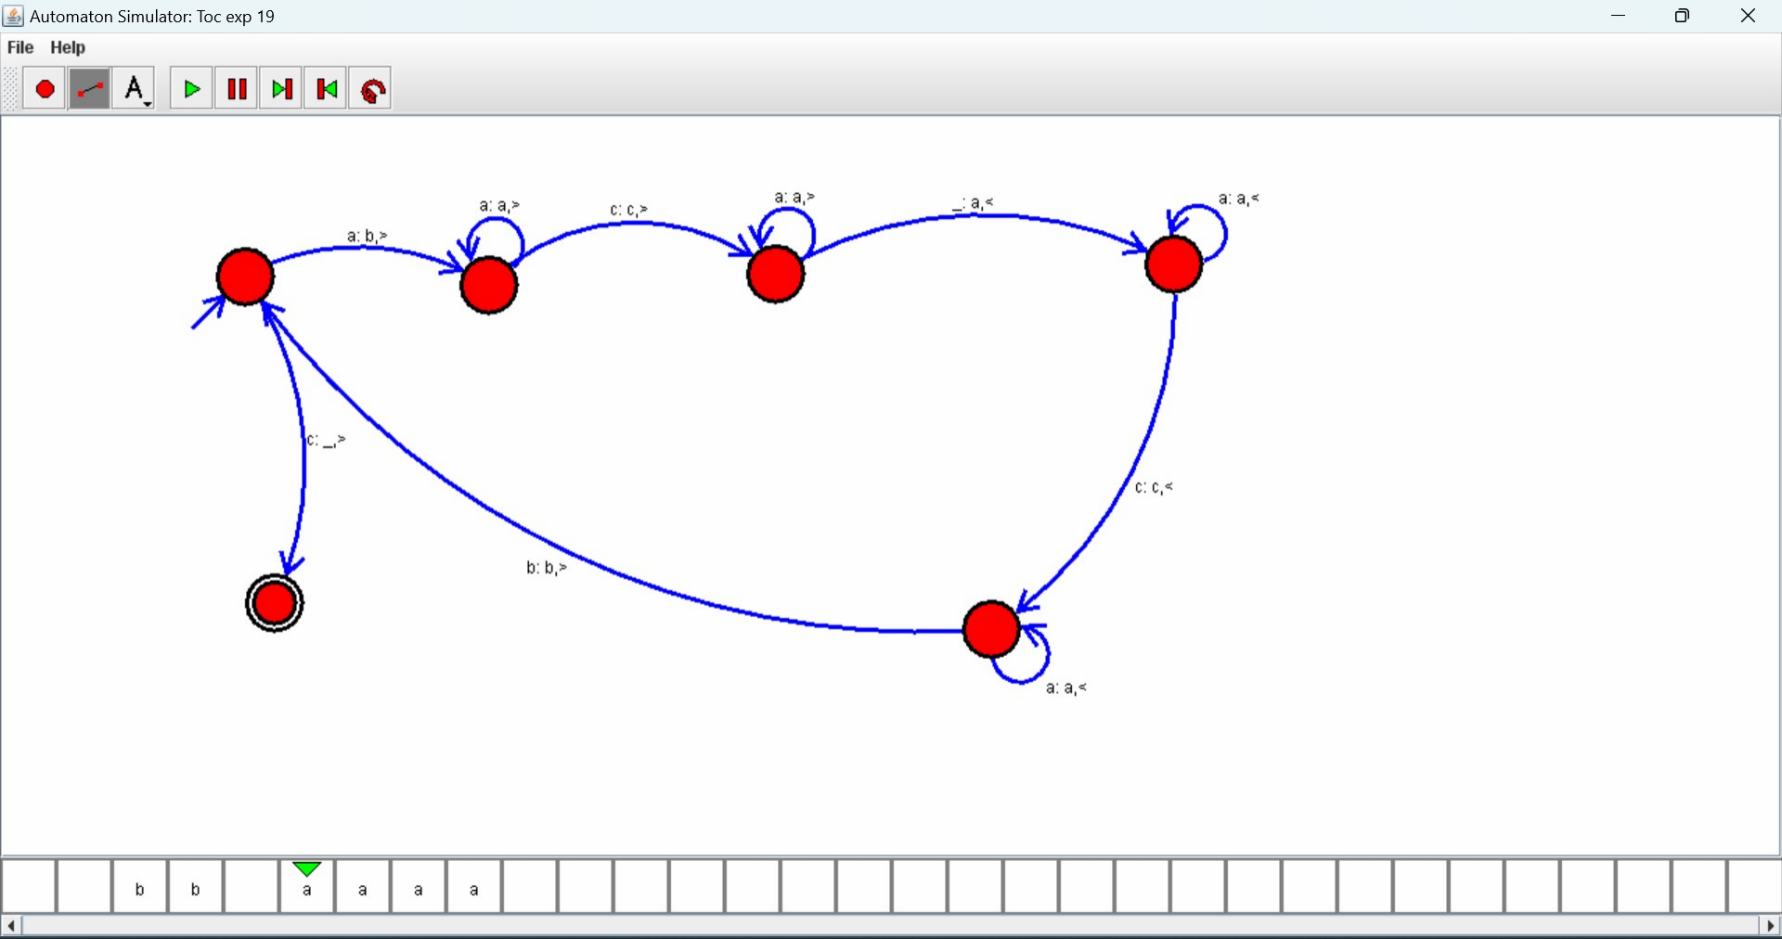

Design TM using simulator to perform subtraction of aaa-aa

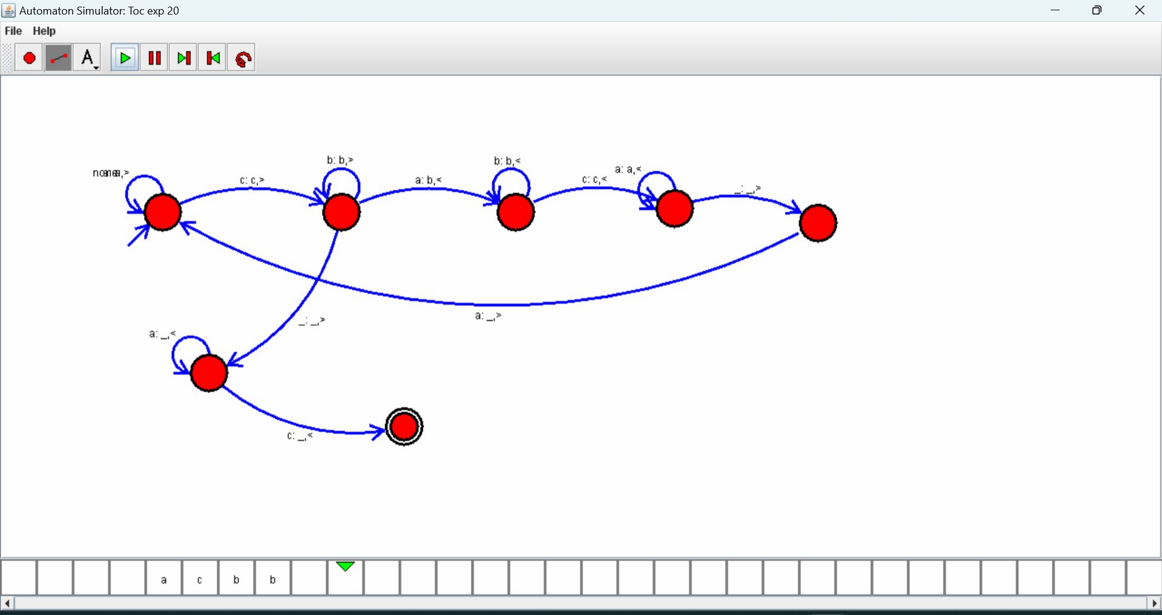

Design DFA using simulator to accept the string the end with ab

over set {a, b)} w= aaabab

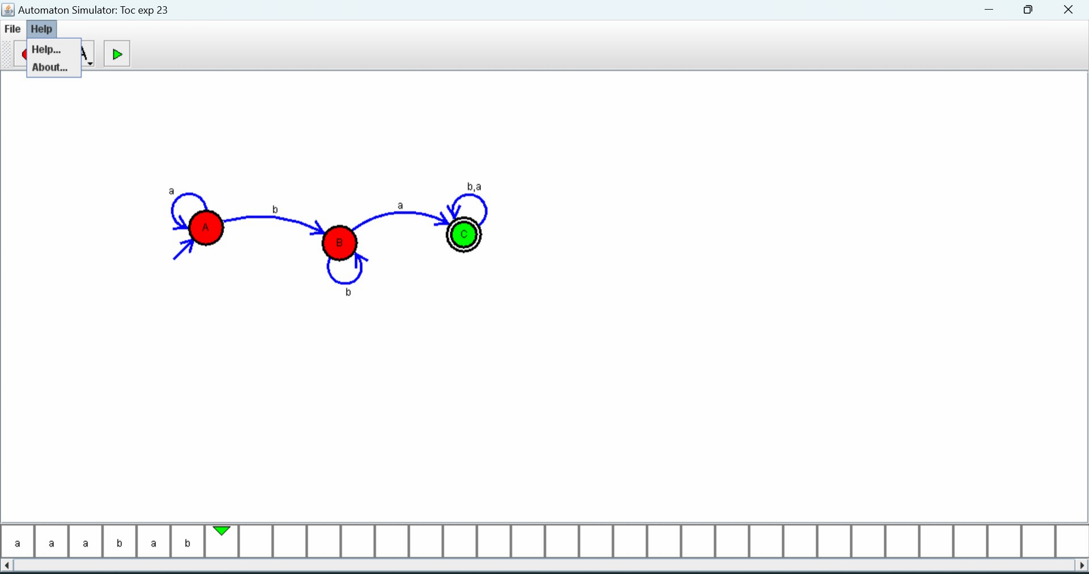

Design DFA using simulator to accept the string having ‘ab’ as

substring over the set {a,b}

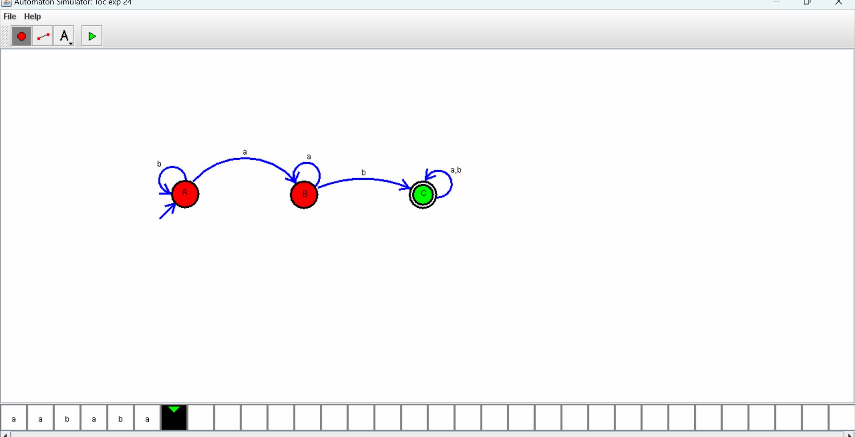

Design DFA using simulator to accept the string start with a or b

over the set {a, b}

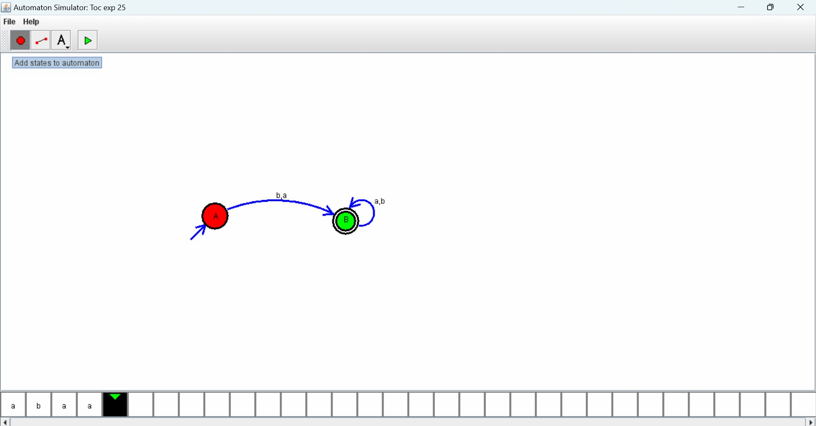

Design TM using simulator to accept the input string Palindrome

Bbabb

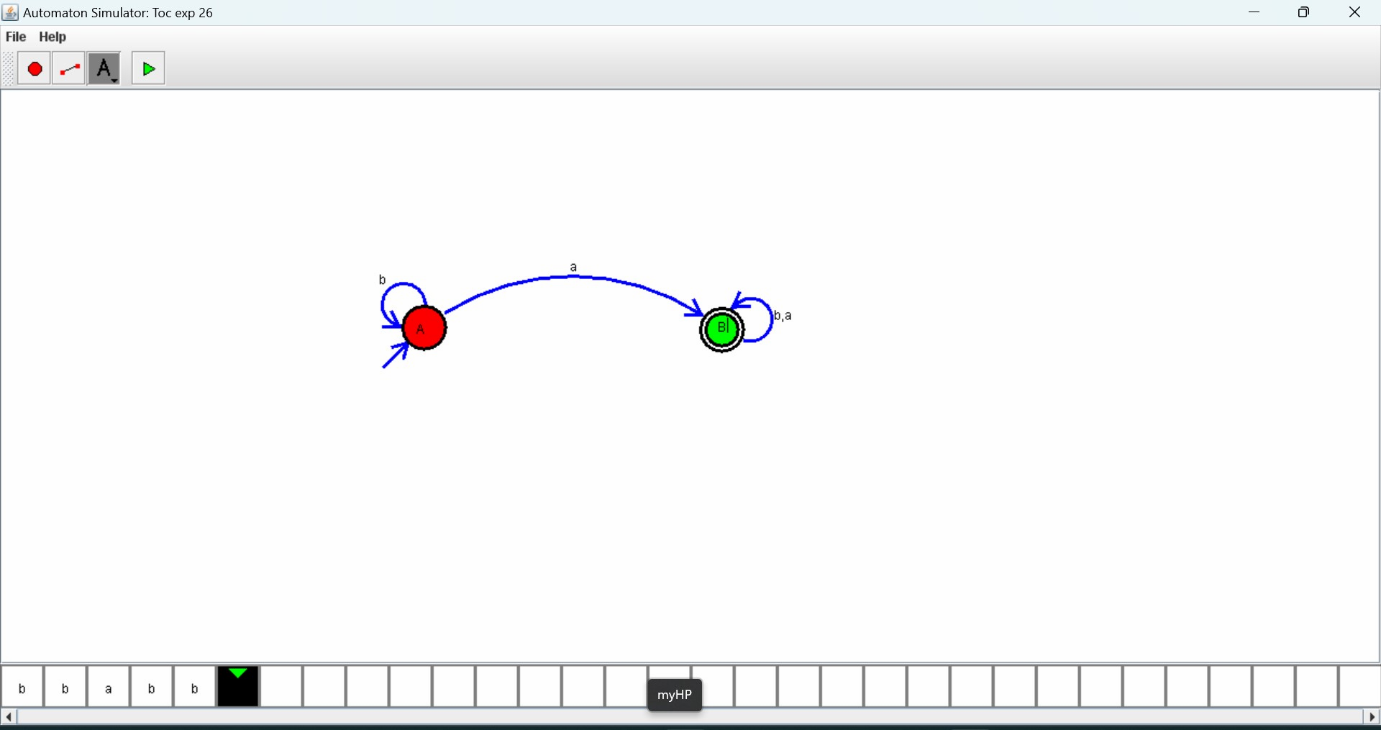

Design NFA to accept any number of a’s where input = {a, b}

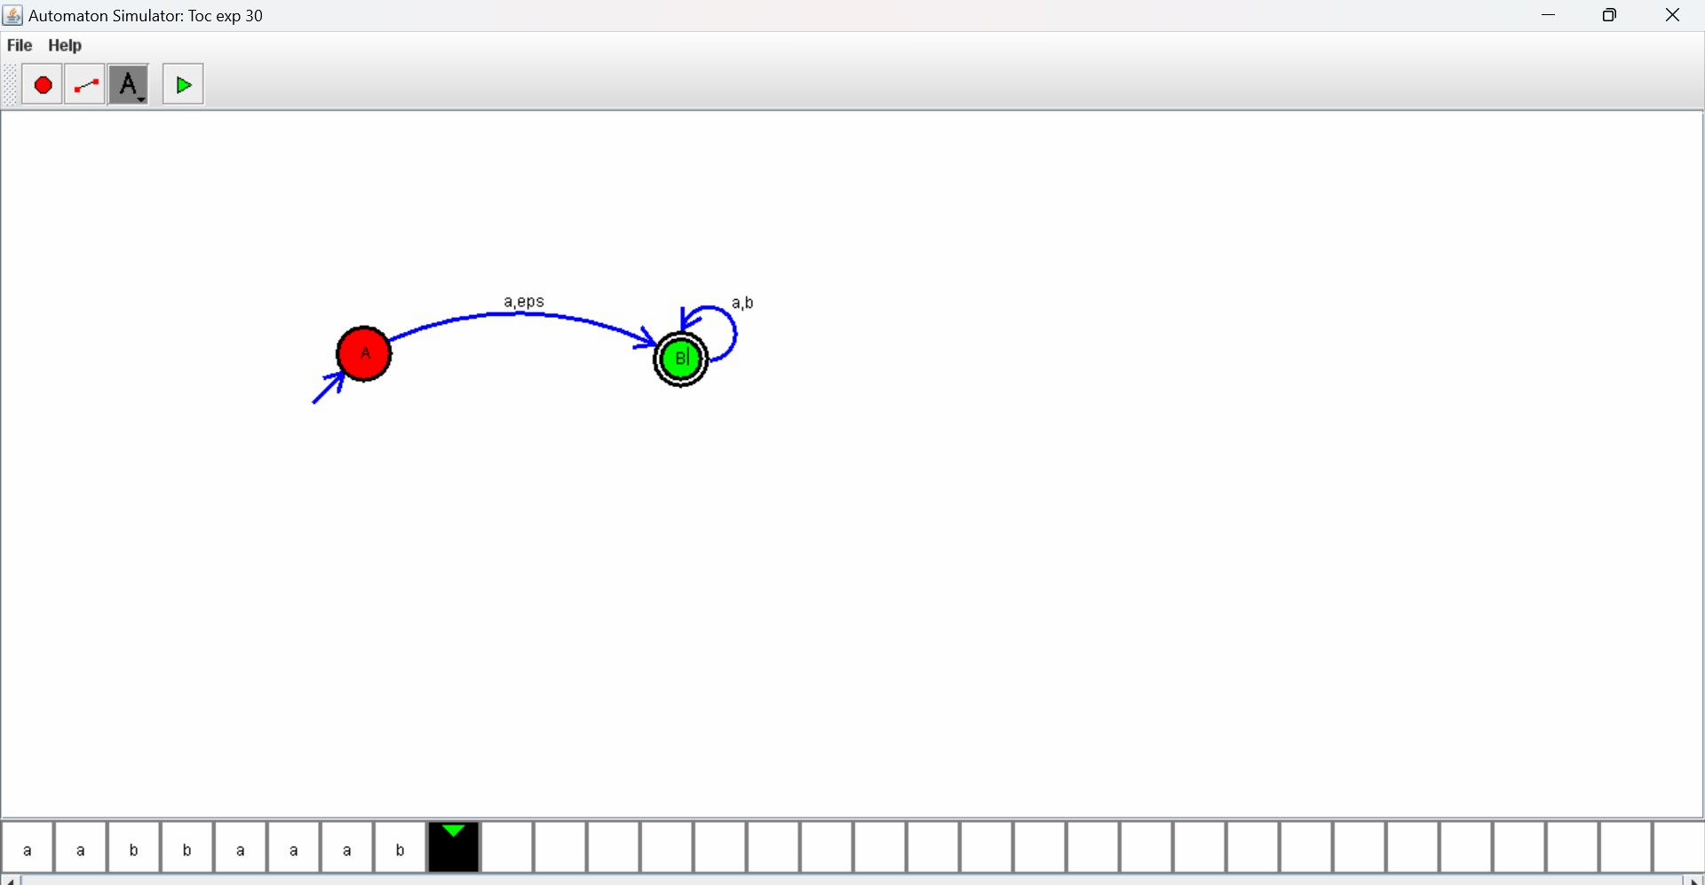

Design PDA using simulator to accept the input string a^nb^n

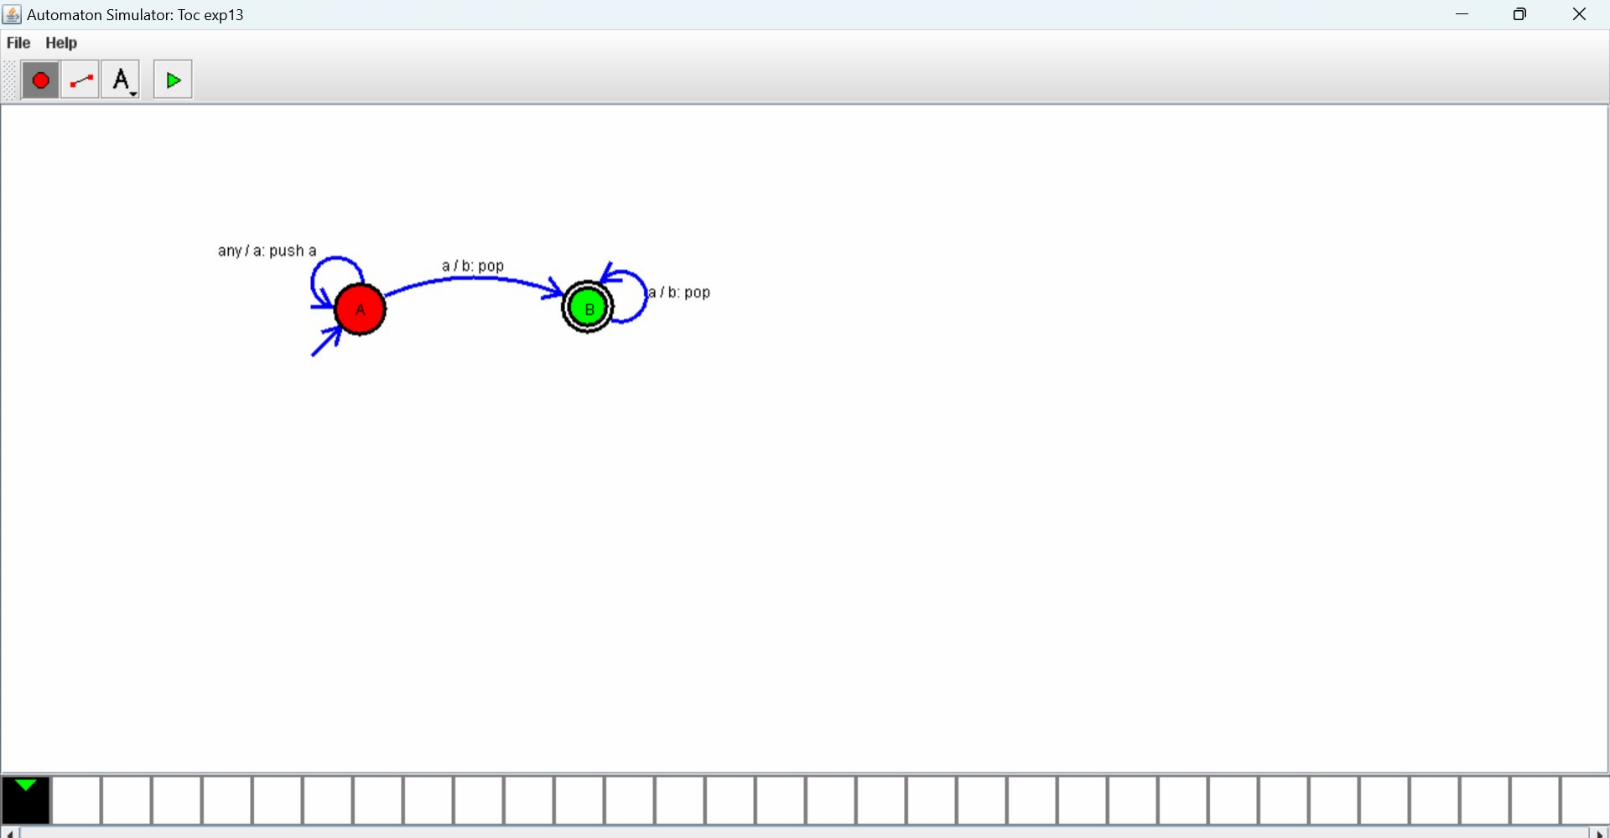

Design DFA using simulator to accept the string having ‘abc’ as

substring over the set {a, b, c}

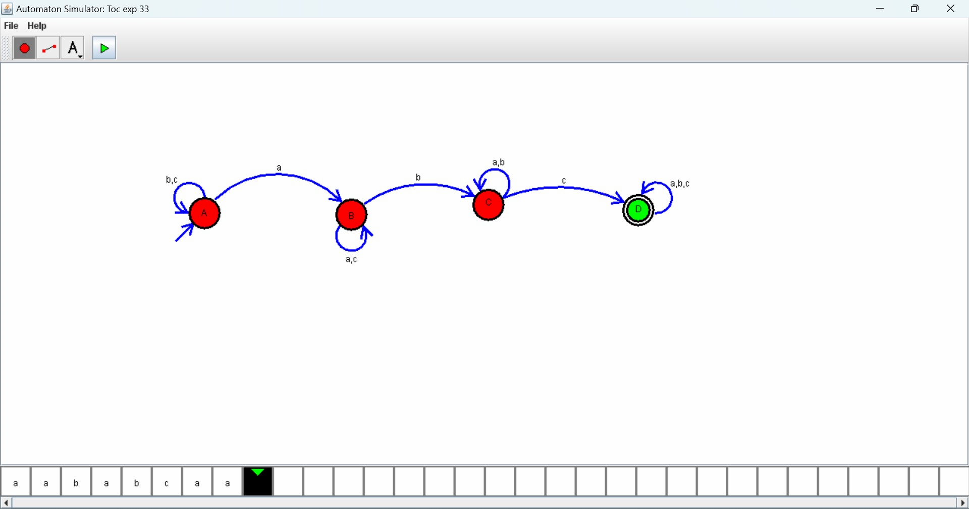

Design DFA using simulator to accept even number of c’s over

the set {a, b, c}

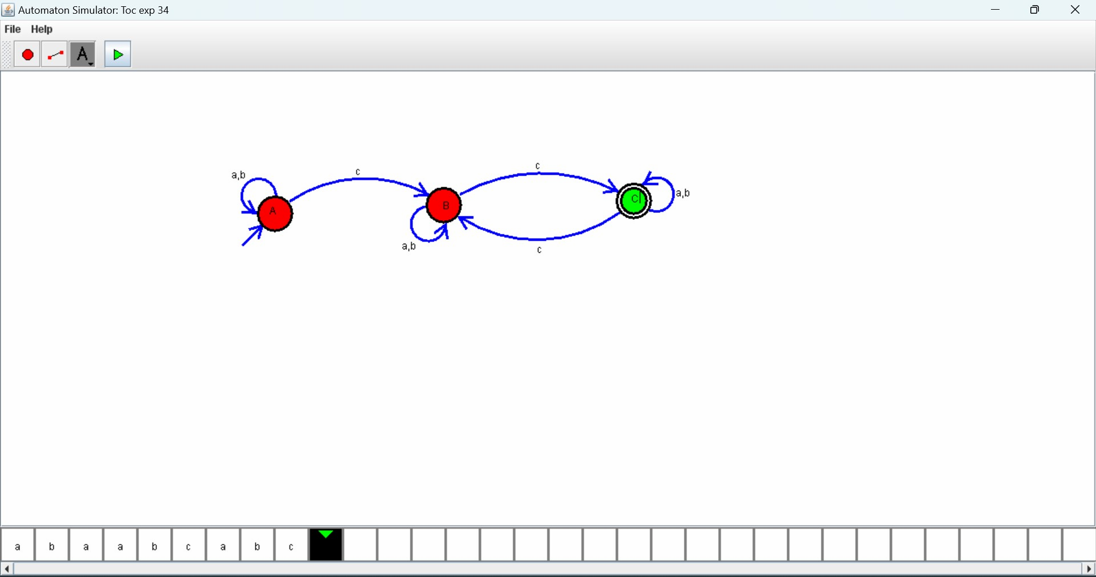

Design DFA using simulator to accept strings in which a’s always

appear tripled over input {a, b}

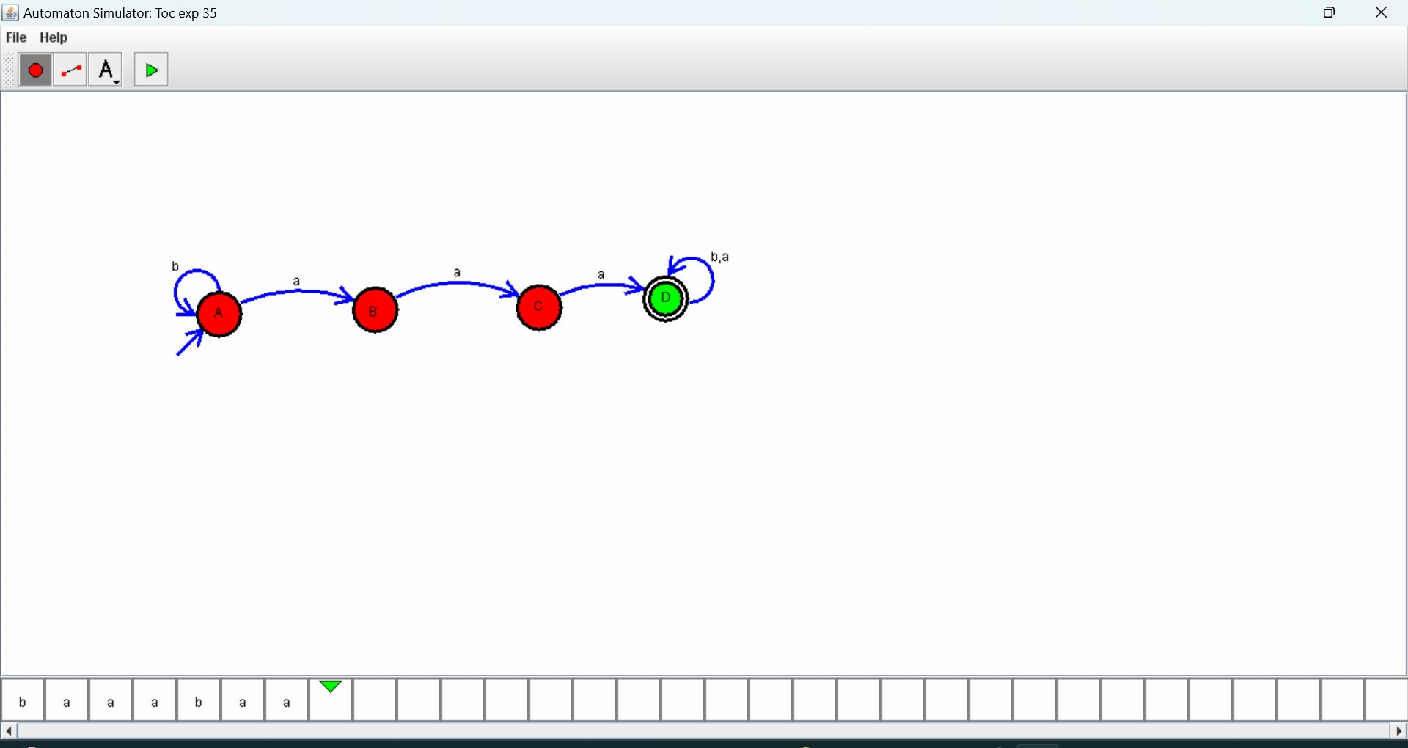

Design NFA using simulator to accept the string the start with a

and end with b over set {a, b} and check W= abaab is accepted or not

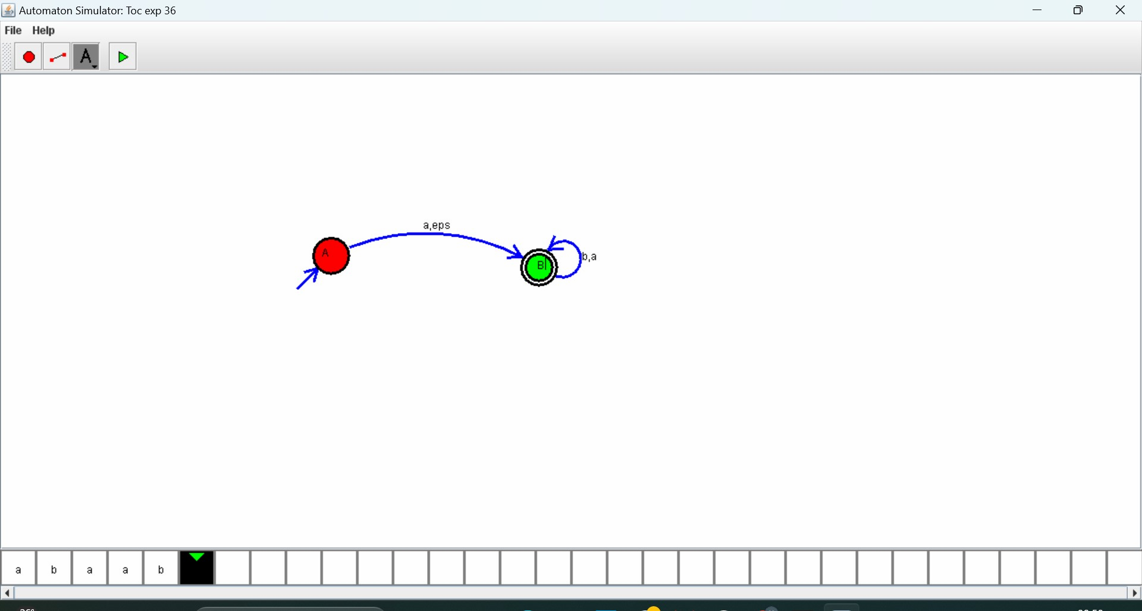

. Design DFA using simulator to accept the string the end with abc

over set {a, b, c) W= abbaababc

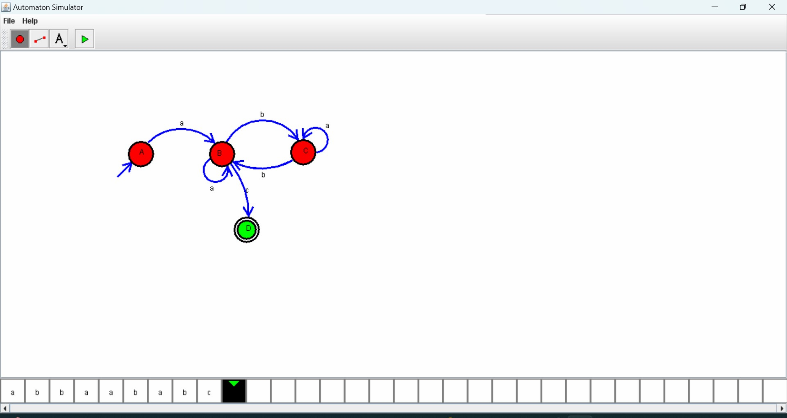

Write a C program to simulate a Deterministic Finite Automata

(DFA) for the given language representing strings that start with a and

end with a.

**PROGRAM:**

#include <stdio.h>

#include <string.h>

int main () {

char String [100];

printf ("Enter a string: ");

scanf ("%s", String);

if (String [0] =='a'&&String [strlen (String)-1] =='a')

{

int i;

for (i=0; i<strlen (String); i++) {

if (String[i]=='0'||String[i]=='1')

{

printf ("Invalid! \n"); return 0;

}

}

printf ("string is accepted\n");

} else {

printf ("Not Accepted\n");

}

return 0;

}

**OUTPUT:**

2. Write a C program to simulate a Deterministic Finite Automata

(DFA) for the given language representing strings that start with 0 and

end with 1.

**PROGRAM**:

#include <stdio.h>

#include <string.h>

int main () { char String [100];

printf ("Enter a string: ");

scanf ("%s", String);

if (String [0] =='0'&&String [strlen (String)-1] =='1')

{

int i;

for (i==; i<strlen (String); i++) {

if (String[i]<'0'||String[i]>'1')

{

printf ("Invalid! \n");

return 0;

}

}

printf ("Valid! The string starts with '0' and ends with '1'.\n");

} else {

printf ("Invalid! The string does not start with '0' and end with '1'.\n");

}

return 0;

}

**OUTPUT:**

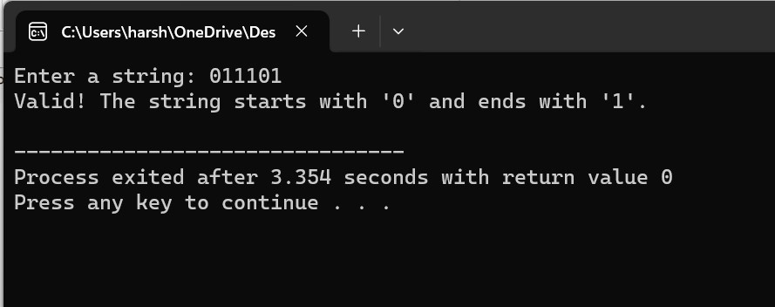

3. Write a C program to check whether a given string belongs to the

language defined by a Context Free Grammar (CFG) S → 0A1 A →

0A | 1A | ε

**PROGRAM:**

#include <stdio.h>

#include <string.h>

int main () {

char String [100];

printf ("Enter a string: ");

scanf ("%s", String);

if (String [0] =='0'&&String [strlen (String)-1] =='1')

{

int i;

for (i==; i<strlen (String); i++) {

if (String[i]<'0'||String[i]>'1')

{

printf ("Invalid! \n");

return 0;

}

}

printf ("Valid! The string starts with '0' and ends with '1'.\n");

} else {

printf ("Invalid! The string does not start with '0' and end with '1'.\n");

}

return 0;

}

**OUTPUT:**

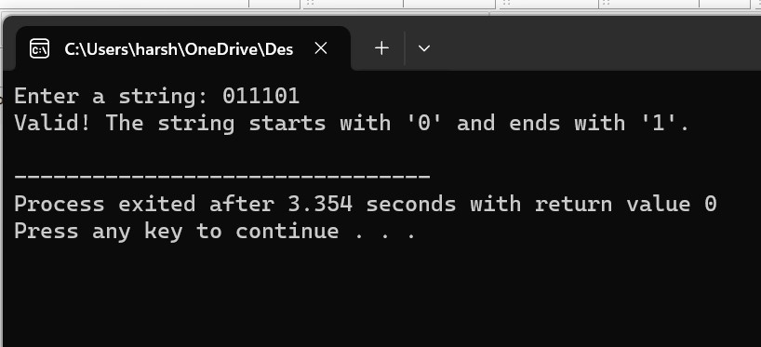

4. Write a C program to check whether a given string belongs to the

language defined by a Context Free Grammar (CFG) S → 0S0 | 1S1 |

0 | 1 | ε.

**PROGRAM:**

#include <stdio.h>

#include <string.h>

int main () {

char String [100];

printf ("Enter a string: ");

scanf ("%s", String);

if (String [0] =='0'&&String [strlen (String)-1] =='1' | | String [0]

=='1'&&String [strlen (String)-1] =='1'))

{

int i;

for (i==; i<strlen (String); i++) {

if (String[i]<'0'||String[i]>'1')

{

printf ("Invalid! \n"); return 0;

}

}

printf ("Valid! The string starts with '0' and ends with '0' or starts with '1'

and ends with '1'.\n");

} else {

printf ("Invalid! The string starts with '0' and ends with '0' or starts with '1'

and ends with '1'.\n");

}

return 0;

}

**OUTPUT:**

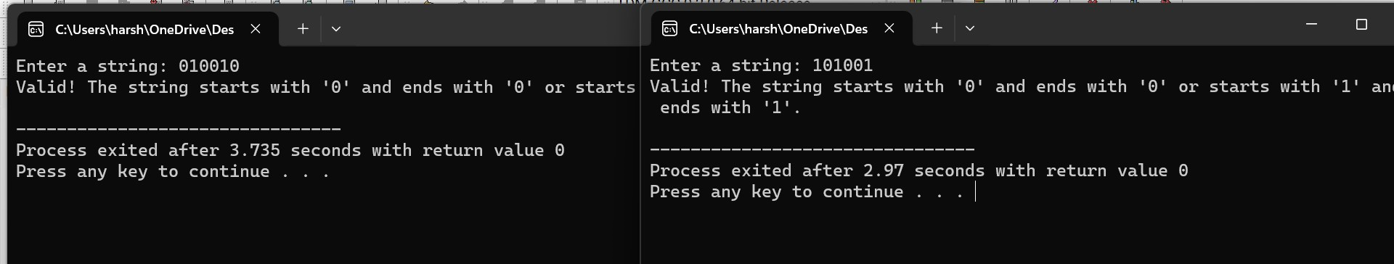

5. Write a C program to check whether a given string belongs to the

language defined by a Context Free Grammar (CFG) S → 0S0 | A

A → 1A | ε

**PROGRAM:**

#include <stdio.h>

#include <string.h>

int main () {

char String [100];

printf ("Enter a string: ");

scanf ("%s", String);

if (String [0] =='0'&&String [strlen (String)-1] =='1' | | String [0]

=='1'&&String [strlen (String)-1] =='1'))

{

int i;

for (i==; i<strlen (String); i++) {

if (String[i]<'0'||String[i]>'1')

{

printf ("Invalid! \n");

return 0;

}

}

printf ("Valid! The string starts with '0' and ends with '0' or starts with '1'

and ends with '1'.\n");

} else {

printf ("Invalid! The string starts with '0' and ends with '0' or starts with '1'

and ends with '1'.\n");

}

return 0;

}

**OUTPUT:**

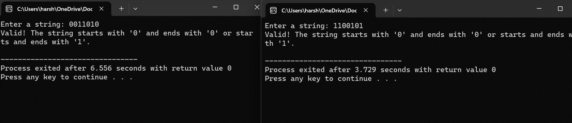

6. Write a C program to check whether a given string belongs to the

language defined by a Context Free Grammar (CFG) S → 0S1 | ε

**PROGRAM:**

#include <stdio.h>

#include <string.h>

int main () {

char String [100];

printf ("Enter a string: ");

scanf ("%s", String);

if (String [0] =='0'&&String [strlen (String)-1] =='1')

{

int i;

for (i==; i<strlen (String); i++) {

if (String[i]<'0'||String[i]>'1')

{

printf ("Invalid! \n");

return 0; }

}

printf ("Valid! The string starts with '0' and ends with '1'.\n");

} else {

printf ("Invalid! The string does not start with '0' and end with '1'.\n");

}

return 0;

**OUTPUT:**

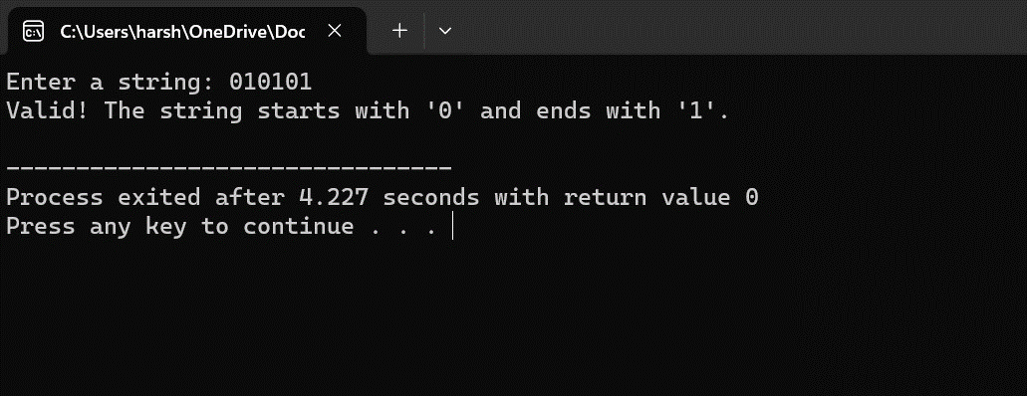

7. Write a C program to check whether a given string belongs to the

language defined by a Context Free Grammar (CFG) S → A101A, A

→ 0A | 1A | ε

**PROGRAM:**

#include <stdio.h>

#include <string.h>

int main () {

char String [100];

printf ("Enter a string: "); scanf ("%s", String);

if (String [0] ==’0’ || ‘1’ &&String [strlen (String)-1] ==’0’ || ‘1’)

{

int i;

for (i==; i<strlen (String); i++) {

if (String[i]<'0'||String[i]>'1')

{

printf ("Invalid! \n");

return 0;

}

}

printf ("Valid! The string starts with '0' or '1' and ends with '0' or '1'.\n");

} else {

printf ("Invalid! The string does not start with '0' or '1' and end with '0' or

'1'.\n");

}

return 0;

}

**OUTPUT:**

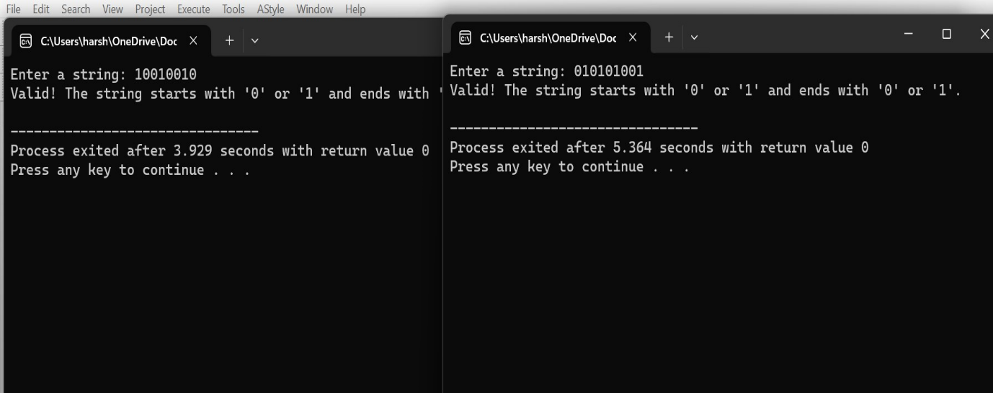

8. Write a C program to simulate a Non-Deterministic Finite Automata (NFA)

for the given language representing strings that start with b and end with a.

**PROGRAM:**

#include <stdio.h>

#include <string.h>

int main () {

char String [100];

printf ("Enter a string: ");

scanf ("%s", String);

if (String [0] =='a'&&String [strlen (String)-1] =='a')

{

int i;

for (i=0; i<strlen (String); i++) {

if (String[i]=='0'||String[i]=='1')

{

printf ("Invalid! \n");

return 0;

}

}

printf ("Accepted\n");

} else {

printf ("Not Accepted\n");

}

return 0;

}

**OUTPUT:**

9. Write a C program to simulate a Non-Deterministic Finite Automata (NFA)

for the given language representing strings that start with o and end with 1.

**PROGRAM:**

#include <stdio.h>

#include <string.h>

int main () {

char String [100];

printf ("Enter a string: ");

scanf ("%s", String);

if (String [0] =='0'&&String [strlen (String)-1] =='1')

{

int i;

for (i==; i<strlen (String); i++) {

if (String[i]<'0'||String[i]>'1')

{

printf ("Invalid! \n"); return 0;

}

}

printf ("Valid! The string starts with '0' and ends with '1'.\n");

} else {

printf ("Invalid! The string does not start with '0' and end with '1'.\n");

}

return 0;

}

**OUTPUT:**

10. Write a C program to find ε -closure for all the states in a Non

Deterministic Finite Automata (NFA) with ε -moves.

**PROGRAM:**

#include <stdio.h>

int main () {

int n; int m;

printf ("Enter the number of states: ");

scanf ("%d", &n);

printf ("Enter the number of transitions: ");

scanf ("%d", &m);

int transitions [3][3];

for (int i = 0; i < m; i++) {

printf ("Enter transition %d (fromState inputSymbol toState): ", i

+ 1);

scanf ("%d", &transitions[i][0]);

char inputSymbol [2];

scanf ("%1s", inputSymbol);

scanf ("%d", &transitions[i][2]);

if (inputSymbol [0] == 'e') {

transitions[i][1] = 'e';

} else {

transitions[i][1] = inputSymbol [0];

}

}

for (int i = 0; i < n; i++) {

printf("e-closure(%d): {%d ", i, i);

for (int j = 0; j < m; j++) {

if (transitions[j][0] == i && transitions[j][1] == 'e') {

printf ("%d ", transitions[j][2]);

} }

printf (“} \n”);

}

return 0;

}

**OUTPUT:**

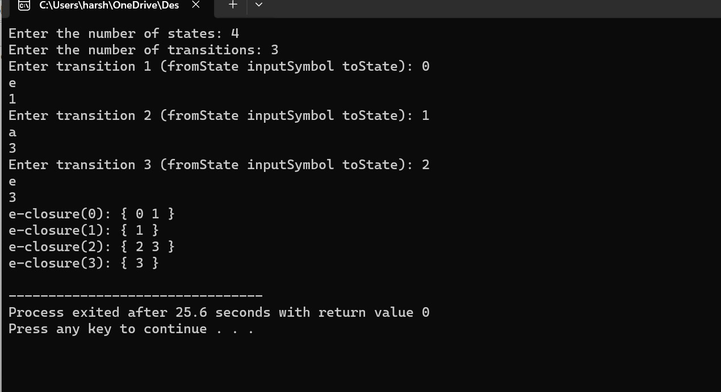

11. Write a C program to find ε -closure for all the states in a Non

Deterministic Finite Automata (NFA) with ε -moves.

**PROGRAM:**

#include <stdio.h>

int main () {

int n;

int m;

printf ("Enter the number of states: ");

scanf ("%d", &n); printf ("Enter the number of transitions: ");

scanf ("%d", &m);

int transitions [3][3];

for (int i = 0; i < m; i++) {

printf ("Enter transition %d (fromState inputSymbol toState): ", i

+ 1);

scanf ("%d", &transitions[i][0]);

char inputSymbol [2];

scanf ("%1s", inputSymbol);

scanf ("%d", &transitions[i][2]);

if (inputSymbol [0] == 'e') {

transitions[i][1] = 'e';

} else {

transitions[i][1] = inputSymbol [0];

}

}

for (int i = 0; i < n; i++) {

printf("e-closure(%d): {%d ", i, i);

for (int j = 0; j < m; j++) {

if (transitions[j][0] == i && transitions[j][1] == 'e') {

printf ("%d ", transitions[j][2]);

}

}

printf (“} \n”);

} return 0;

}

**OUTPUT:**

